Honeywell Voyager XP 1470g
Tastatur-Modus
05.05.2025
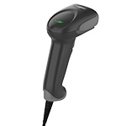
Reset the Custom Defaults: Activate Custom Defaults
Beeper Volume - Good Read: Low
Cellular Telephone Reading Mode: On
Program Keyboard Country: Germany
Keyboard Modifiers: Windows Mode Control + X
Dead Key Thru Alt+Numpad Sequence: Windows System Code Page
Prefix: STX
Suffix: ETX


DEFALT;BEPLVL1;KBDCTY4;KBDCAS2;KBDALT4;HSTACH18;HSTDCH20;DECCEL1;PREBK29902;SUFBK29903.

